Actions
Access Azure Data Factory from azure portal.
- 1. Login into Microsoft Azure
- 2. Select Resource groups from left pane.
- 3. Select appropriate Subscription Dev/UAT/Application
- 4. Click on desired resource group information_insights_ingest_batch_shared or information_insights_analytics
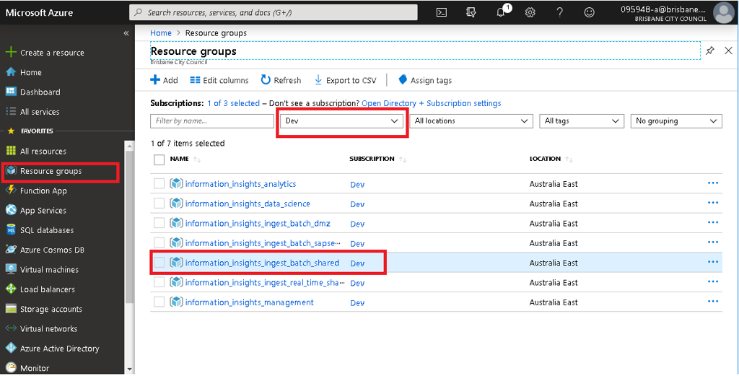
- 5. click on Data Factory resource devinsightadf02/devinsightadf01 or uatinsightadf02/uatinsightadf01 or prdinsightadf02/prdinsightadf01.
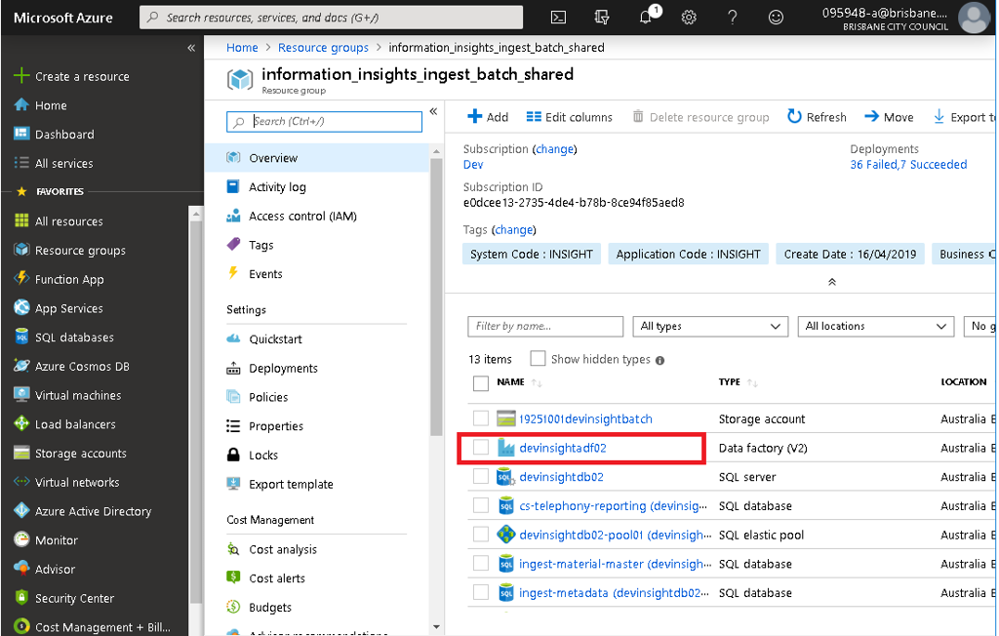
- 6. Click on Author & Monitor following screen will come
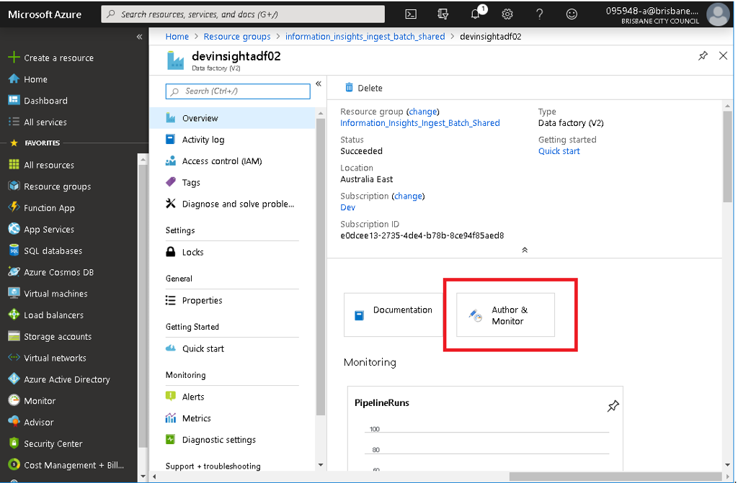
- 7. Click on pen left side of the pane.
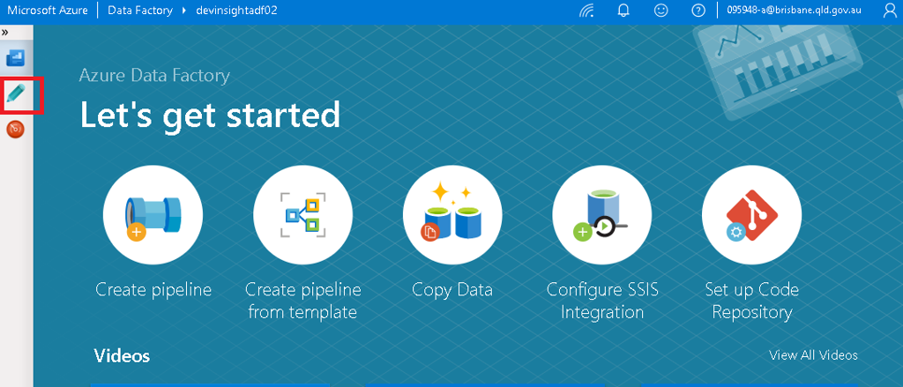
- 8. Click on the appropriate pipeline.
- 9. Then click on Trigger , it will give you two option Trigger now and New/Edit
- 10. To Execute the pipeline click on Trigger Now then click on Finish.
- 11. To schedule or reschedule the pipeline click on New/Edit
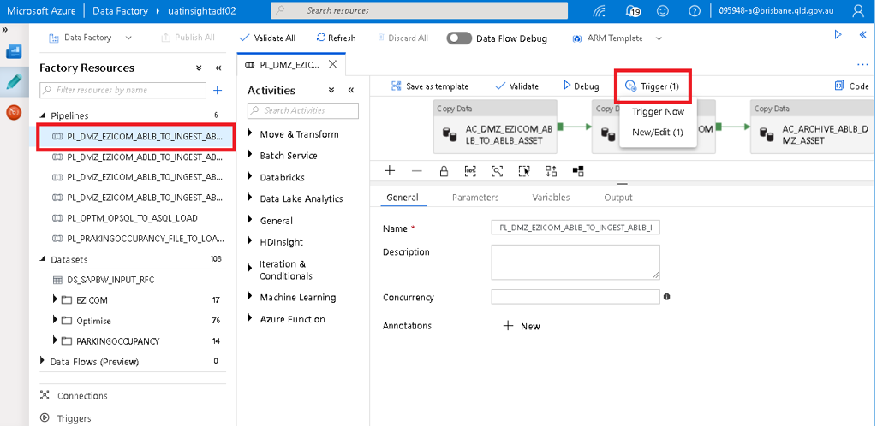
- 12. To schedule the pipeline Click on New as indicated in the screen shot
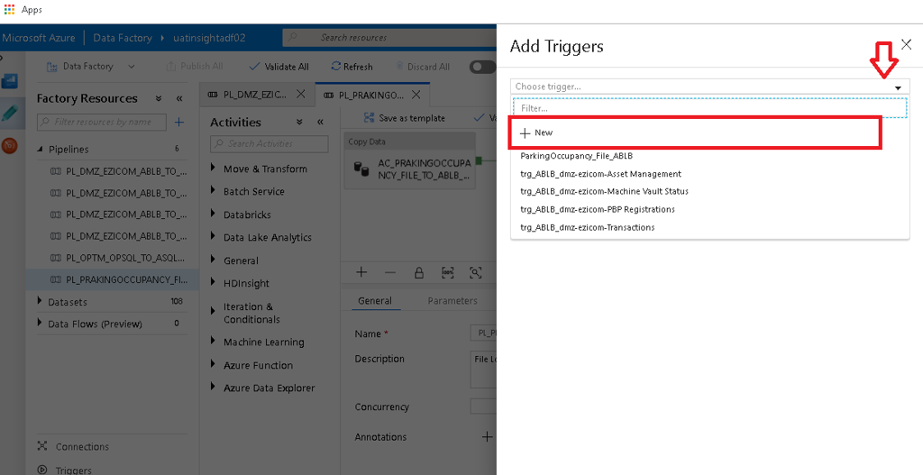
- 13. Give the appropriate name to the trigger as per the naming convention
- 14. If you want to schedule on particular date and time the click the radio button Schedule and Give the Start Date and Time in UTC
- 15. Specify the Recurrence as required.
- 16. Specify the End date as mentioned in the deployment guide.
- 17. Click on Yes radio button in the Activated section to activate the trigger
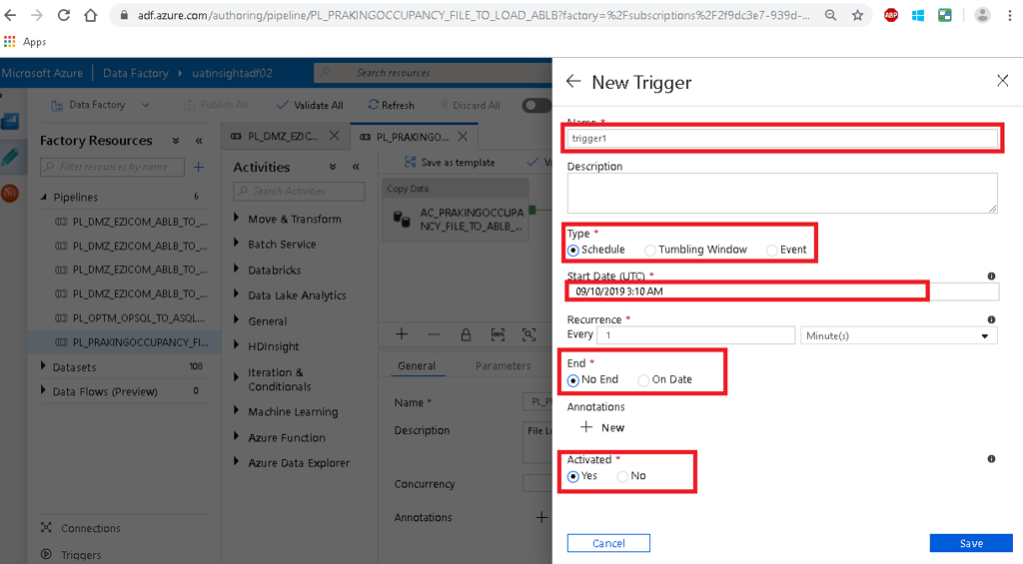
- 18. For the Event base trigger select _Event and Select the appropriate Azure Subscription from drop down list
- 19. Then select appropriate Storage account name from drop down list
- 20. Then Specify the _Container name
- 21. Specify the bob name if you have specific file or leave blank
- 22. Select the appropriate Event type
- 23. Click on Yes radio button in the Activated section to activate the trigger
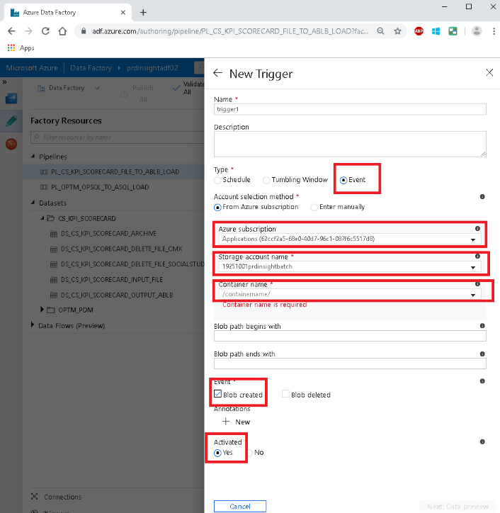
Rerun the Pipeline
- 24. Click on Red Button on the left pane
- 25. Then select the Pipeline which need to be run again.
- 26. Click on the check box near to the Pipeline Name.
- 27 Then Click on the Rerun as indicated in the screen shot.
